**43. Template Actions**

--- service.yml

apiVersion: v1

kind: Service

metadata:

  name: {{ include "firstchart.fullname" . }}

  labels:

    {{- include "firstchart.labels" . | nindent 4 }}

spec:

  type: {{ .Values.service.type }}

  ports:

    - port: {{ .Values.service.port }}

      targetPort: http

      protocol: TCP

      name: http

  selector:

    {{- include "firstchart.selectorLabels" . | nindent 4 }}

--- **note** - One of the basic and most used Helm templating syntax or elements is actions. Actions start with two flower brackets and end with two flower brackets. Within these actions, we can use several other elements from the helm templating syntax, such as defining variables, using conditional logic, using loops, invoking functions and all of that just like any other programming language.

--- So, in our template files, anything outside of these action elements, what you see here up top will be rendered as it is in the output. This labels, the spec the replicas. All these will be rendered as it is, but whatever you have inside these action elements, they will be evaluated dynamically.

--- So here you can write all the logic you want using the helm templating syntax, conditional statements, looping statements variables invoking functions, which will be learning in the next few lectures.

**Define an action in deployment.yml**

--- So, let us start by defining a basic action up top here.

--- vi deployment.yml

apiVersion: apps/v1

kind: Deployment

**{{- "Helm templating is"}}, {{- "cool"}}**

metadata:

  name: {{ include "firstchart.fullname" . }}

  labels:

    {{- include "firstchart.labels" . | nindent 4 }}

spec:

  {{- if not .Values.autoscaling.enabled }}

  replicas: {{ .Values.replicaCount }}

  {{- end }}

  selector:

    matchLabels:

      {{- include "firstchart.selectorLabels" . | nindent 6 }}

  template:

    metadata:

      {{- with .Values.podAnnotations }}

      annotations:

        {{- toYaml . | nindent 8 }}

      {{- end }}

      labels:

        {{- include "firstchart.selectorLabels" . | nindent 8 }}

--- **important** - This hyphen is to remove any trailing or leading white spaces. So yaml is very strict when it comes to indentation. To avoid any errors, we use hyphen so that there are no unnecessary leading or trailing spaces,

**# To see the template of firstchart**

--- helm template firstchart

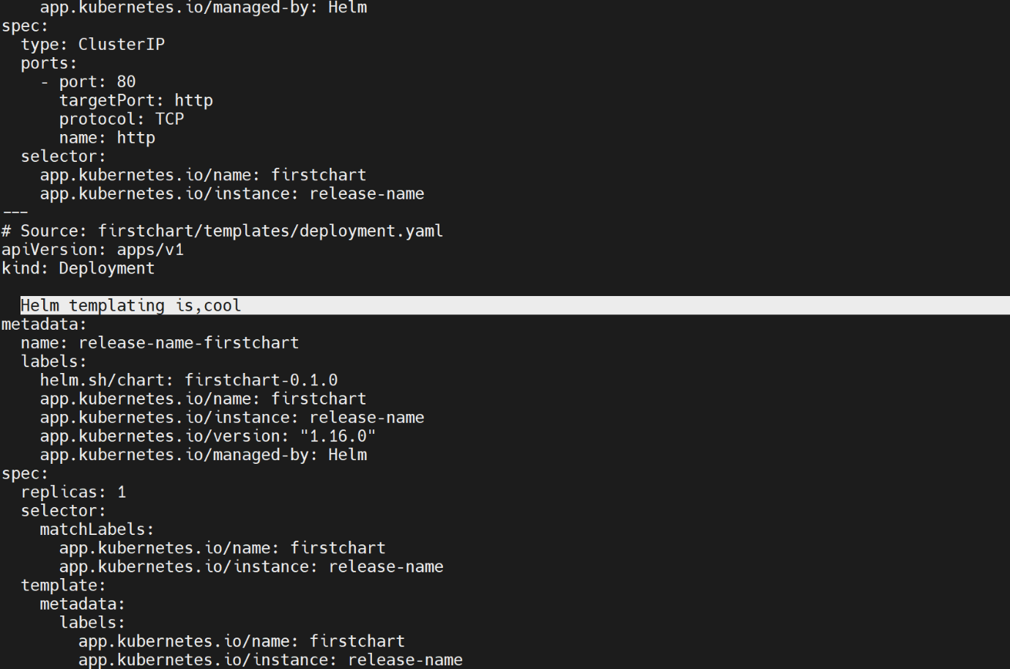

--- **note** – see the output.